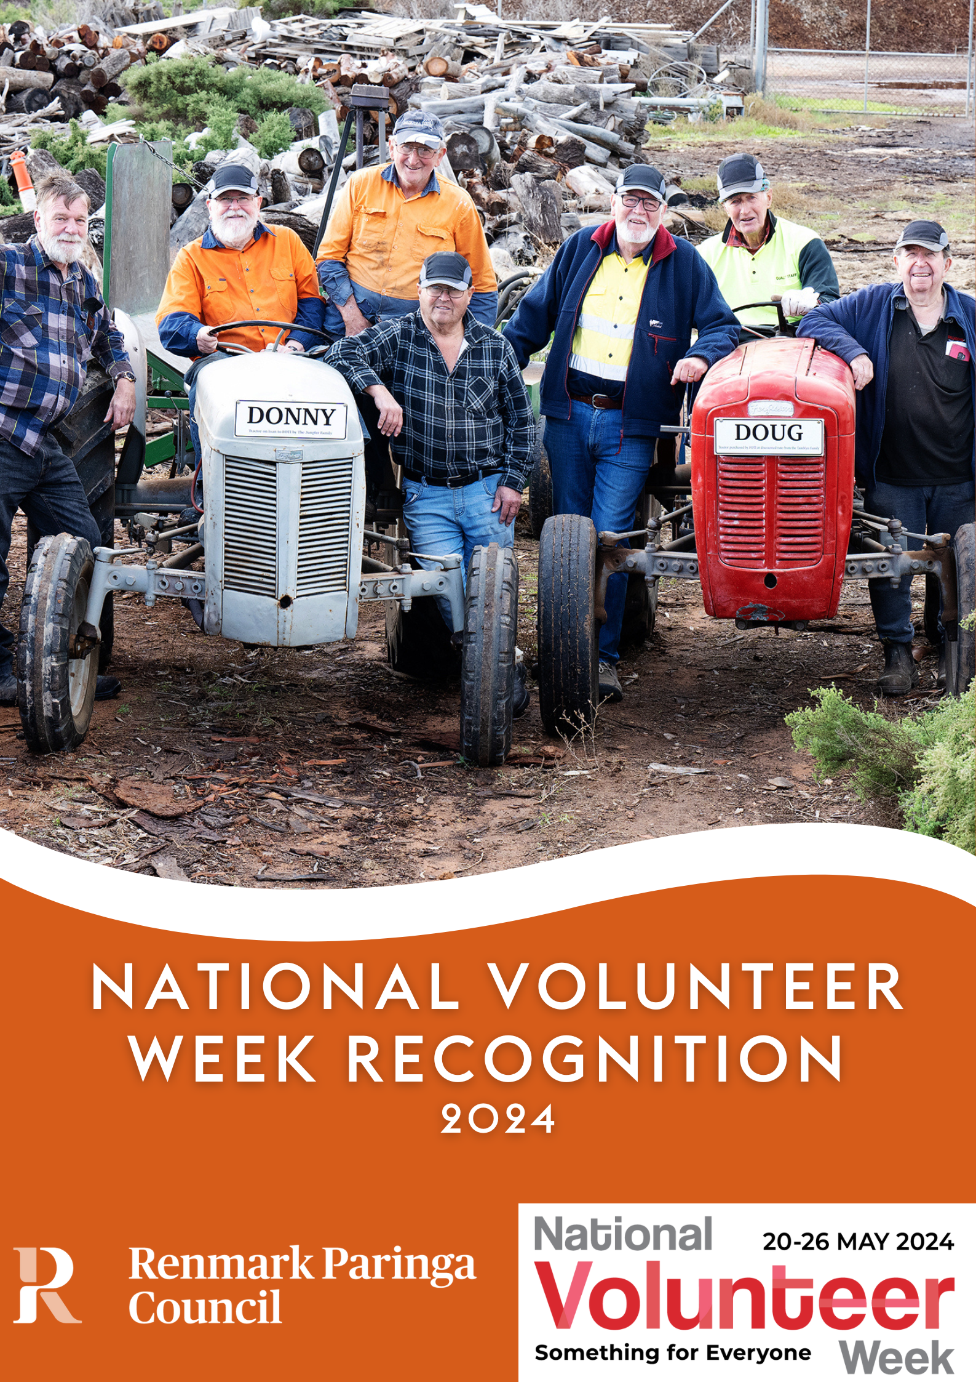

Do you know someone who has been volunteering at their club for a number of years or has made a significant contribution to their club?
Introduction

Procedure for nominating

Categories

National Volunteer Week will be celebrated from 20-26 May 2024. It recognises individuals that have made a significant contribution to their sporting club, service club or community group and / or given an outstanding service over a number of years. There is also an option to recognise a group of volunteers who have been involved in an event or project at your club or group.

A certificate of recognition will be presented to all nominated individuals and groups at a morning tea on Monday 20 May 2024 from 10.30am to 11.30am at the Hotel Renmark Function Room.

Complete this form and return to council by 10am Monday 13 May 2024.

All enquiries can be directed to Renmark Paringa Council 8580 3000 or council@renmarkparinga.sa.gov.au

How to get your nomination form to Council:
Post: Renmark Paringa Council, PO Box 730, Renmark SA 5341
Deliver: Renmark Paringa Community & Civic Centre,
61 Eighteenth Street, Renmark SA 5341
Email: council@renmarkparinga.sa.gov.au

If required, additional material may be attached to your nomination.

Service Recognition: To be eligible the person must be volunteering within Renmark Paringa Council area and have been volunteering at one club for 10,15, 20, 25 or 30 years plus.

Significant Contribution Recognition: To be eligible the person must be volunteering within the Renmark Paringa Council area and have made a significant contribution to the club/group they are involved in.

Club Event or Project Recognition: To be eligible the person/group must have assisted with organising an event or significant project at their club/group. The event or project must have been held during the past year (2023) in the Renmark Paringa Council area.

Nominations close at 10am Monday 13 May 2024

National Volunteer Week Recognition - Nomination Form

1. Nominee Details (the person/organisation you would like to nominate). Please provide as much information as possible – leave blank any questions that don’t apply.
Recognition Category (please tick) | Service  (years) please specify |  | Significant Contribution |  | Club Event or Project
Name of person or group you are nominating
Postal address of nominee
Phone and Email of nominee
Club/s and/or group/s the nominee volunteers with
How many years have they been volunteering at each club or group for? | (If exact years are unknown, please provide an approximate)
Reason for nomination –
If nominating a group
provide details on their
project or event, if
nominating an individual
explain their role at the
club/group and their
achievements.

2. Nominator (your details)
Your name
Your address
Your contact phone
Your email

Office Use Only
Date Received

Incoming Mail
Registration Number

